

# EE2024 CUTE Project

# Lab Report

**Done By :** Tan Yu Peng, A0143884W

: Chong Ze Xuan, A0138915X

**Group :** TU1

**Date :** 12 April 2017

**Assessing GA :** Chattopadhyay Rajarshi

# Contents

Introduction and Objectives 4

Flowcharts 4

Description and Explanation of Implementation 18

Setup for Interrupts and Handlers and Routines 18

EINT1 Interrupt from SW4 Button 18

EINT0 Interrupt from SW3 Button 19

Timer Interrupts for 7 Segment Display and RGB LED 19

Light Interrupts 20

Normal Functions 21

Sample Temperature, Light Sensors, Accelerometer 21

7 Segment Display 22

OLED Display 23

UART Message Transmission 24

Application Logic Enhancements 25

Screens Displaying Larger Text 25

Function Mode Page 26

Rotary Switch and Joystick UI Navigation 27

Problems and Solutions 29

SSP / I2C Bus Contention 29

Accelerometer Interrupts 29

OLED and RGB LED Conflict 29

OLED Graphic Glitches 29

USB Keyboard Integration Attempt 29

Suggestions/Issues 30

Conclusion 30

# Introduction and Objectives

The Care Unit for The Elderly (CUTE) device is designed for use by the elderly to monitor their status. The device is wireless connected to the Centralized Elderly Monitoring System (CEMS) agency which allows them to monitor the CUTE users at a centralized location.

It has temperature sensors to detect abnormal temperatures e.g. during a fire, a light sensor to detect low lighting conditions and an accelerometer to detect motion and orientation.

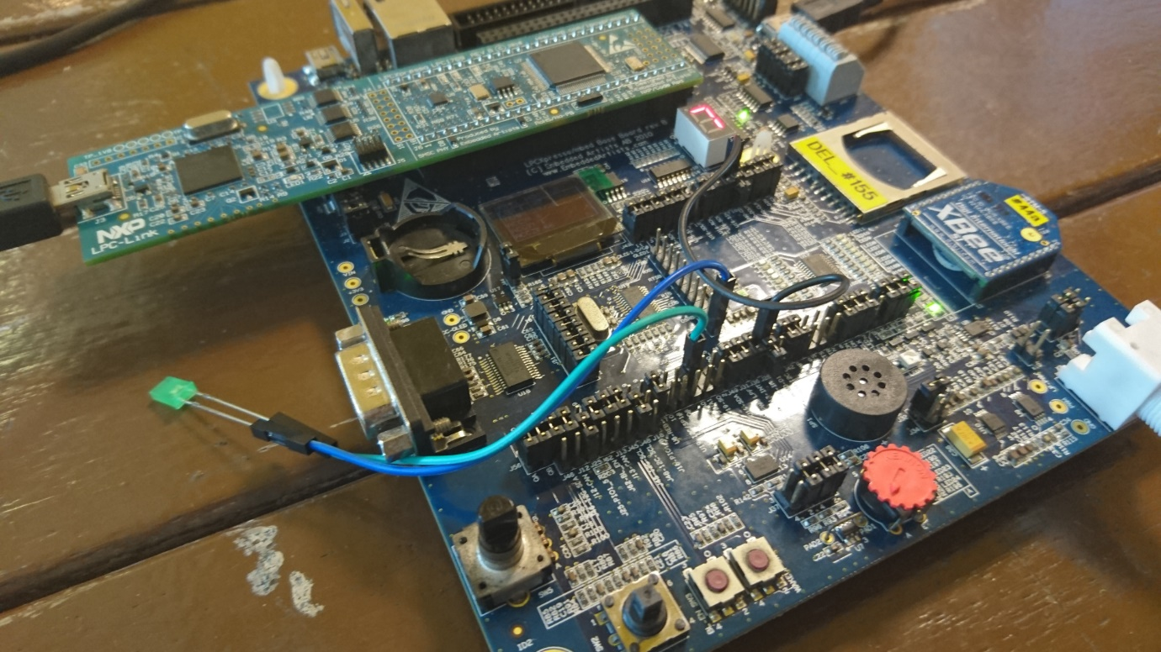

Figure 1: LPC1769 Board and XBee module attached to LPCXpresso Board

We implement our design by using a prototyping board, which allows for easier debugging in the development of our solution. The prototyping device that we are using are the LPC1769 development board and the LPCXpresso base board which contains all the sensors and peripherals we would need to implement our features. We are using the XBEE® S1 802.15.4 RF Module for low power wireless data communications between CUTE and CEMS.

The objectives of our CUTE device are as follows:

1. Track the user’s environment and movement
2. Alert the user and CEMS if there is a fire detected
3. Alert the user and CEMS if there is movement detected in darkness
4. Provide a way for the user to alert others nearby if they require assistance
5. Provide a way for the user to notify CEMS for assistance
6. Provide a way for the user to illuminate their environment

# Flowcharts

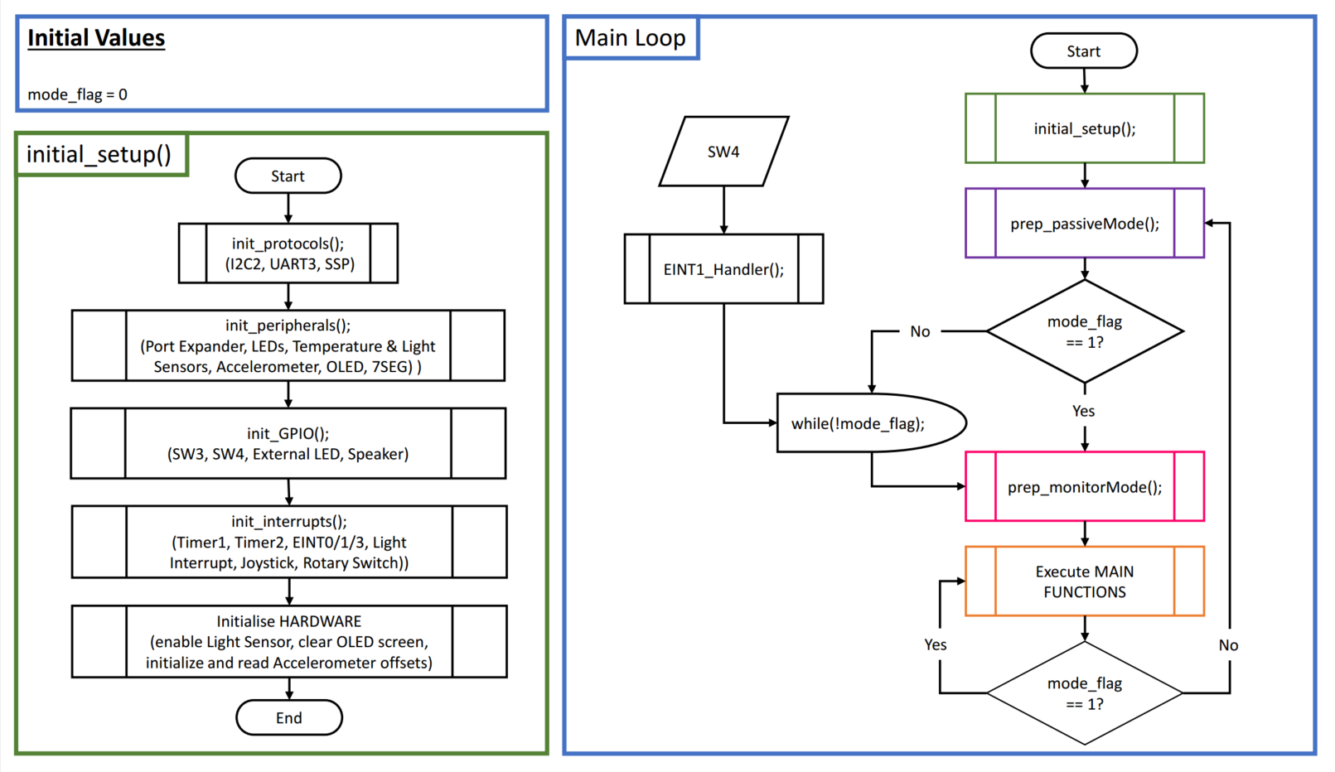

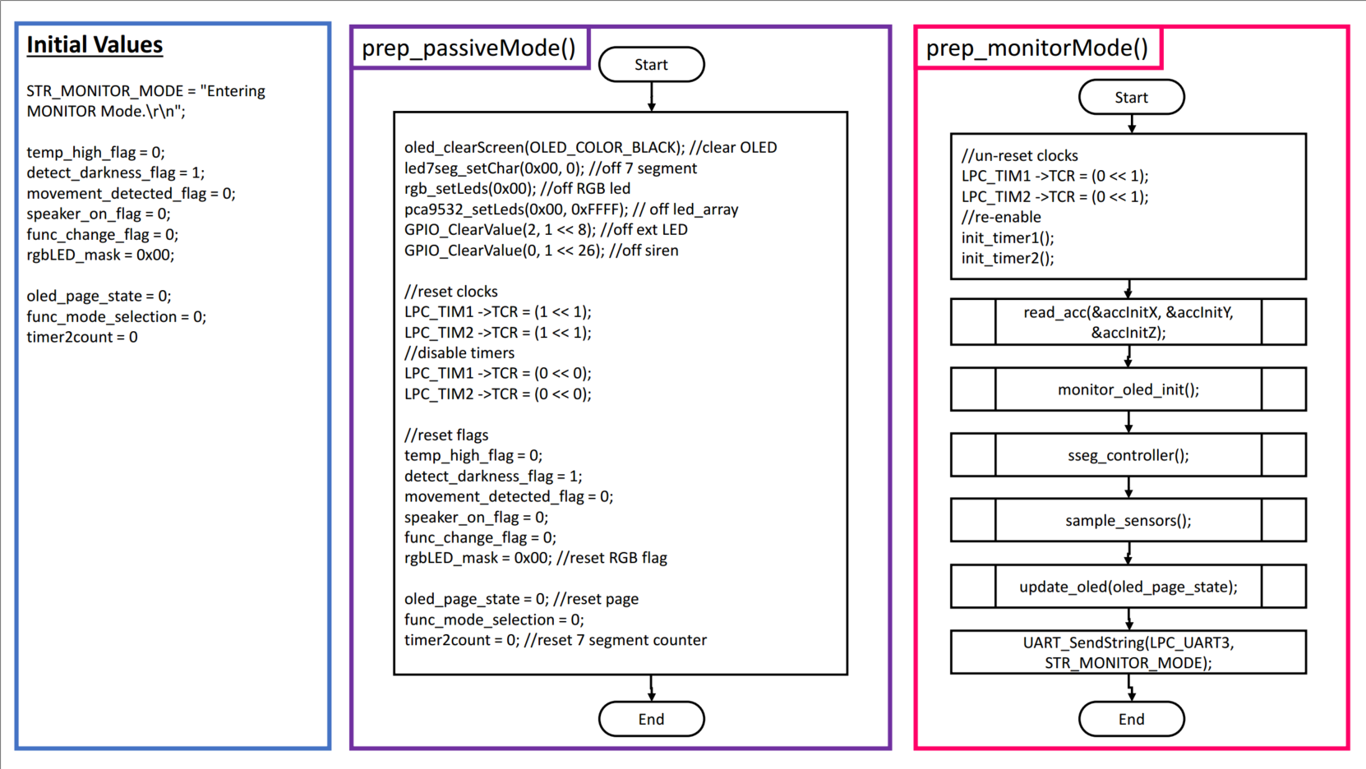

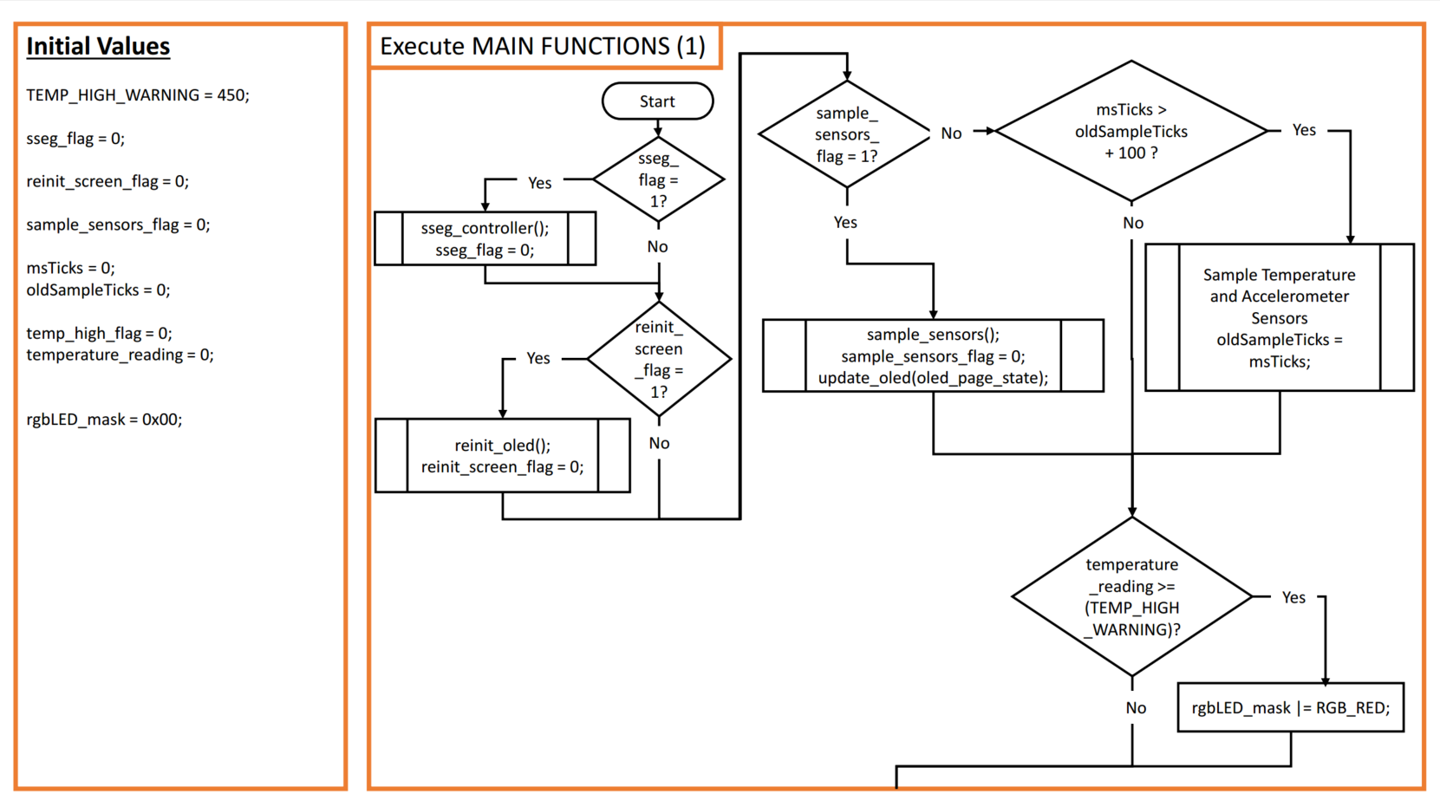

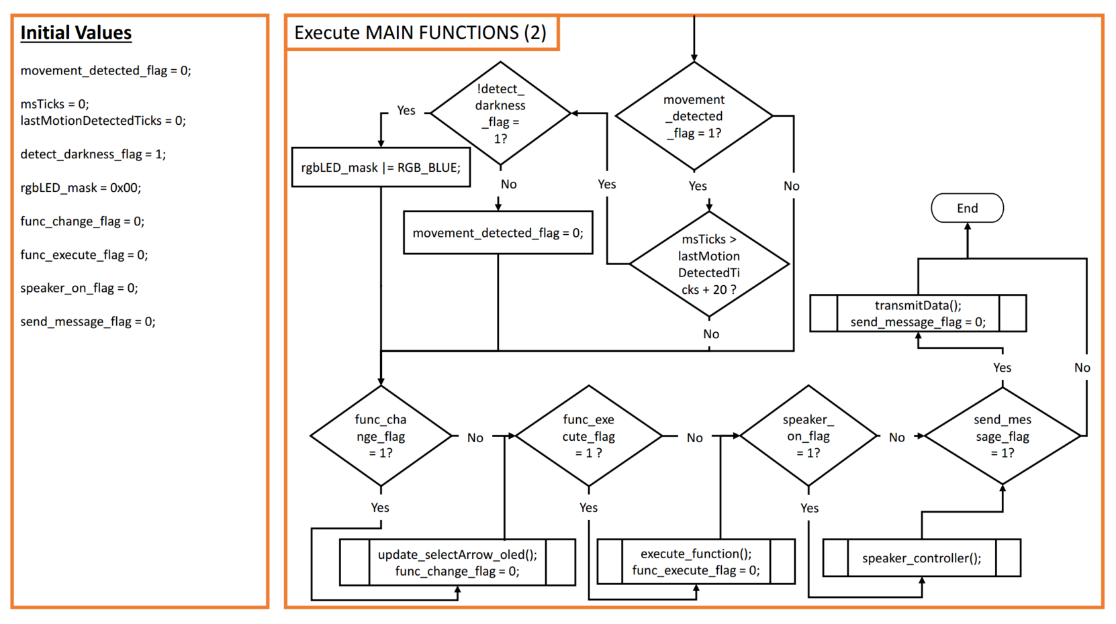

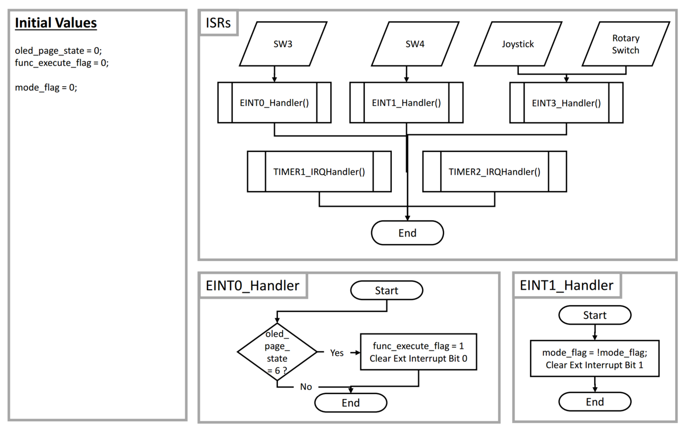

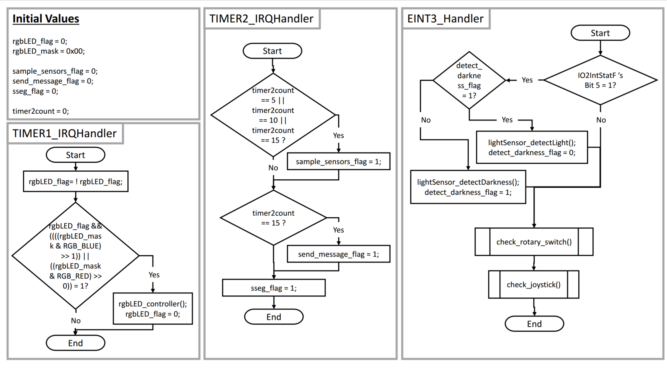

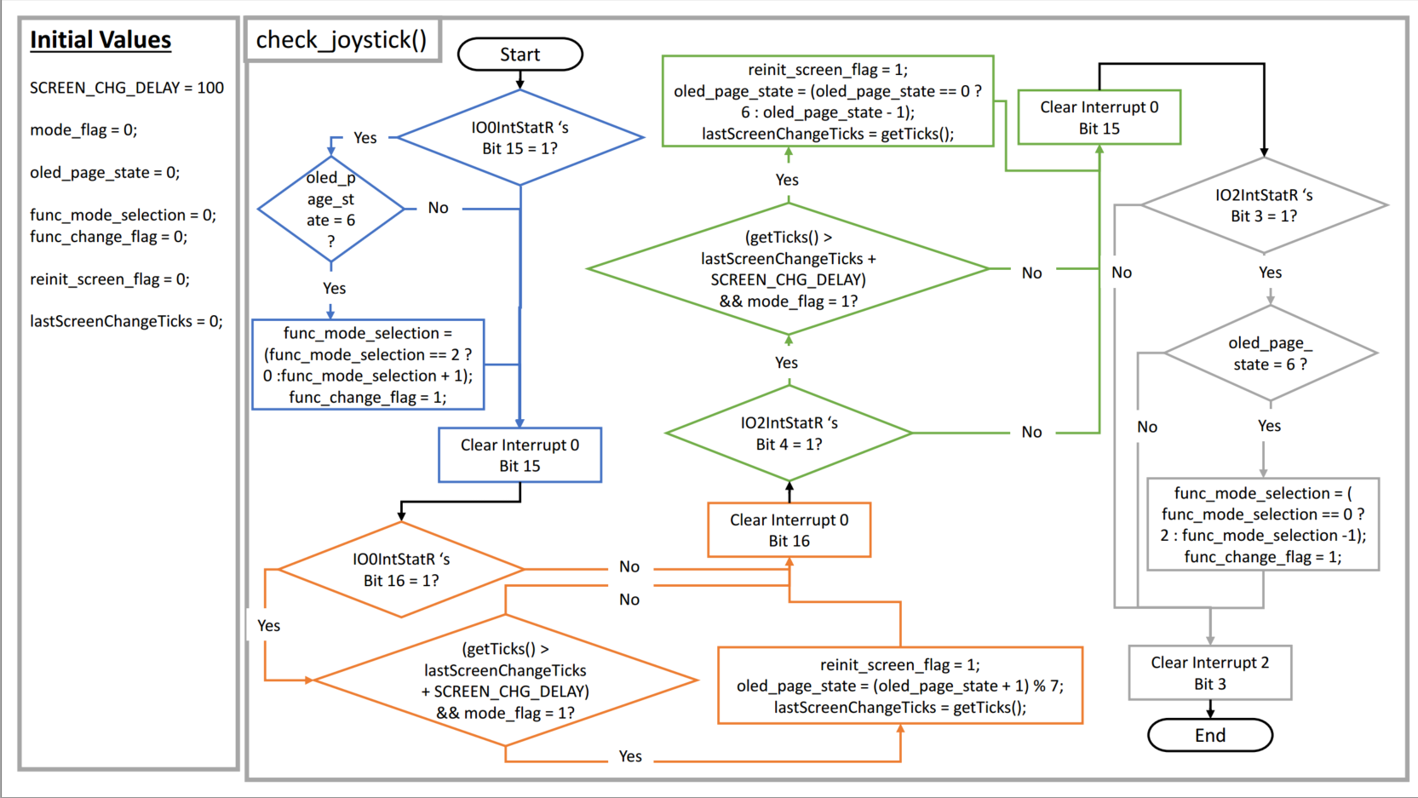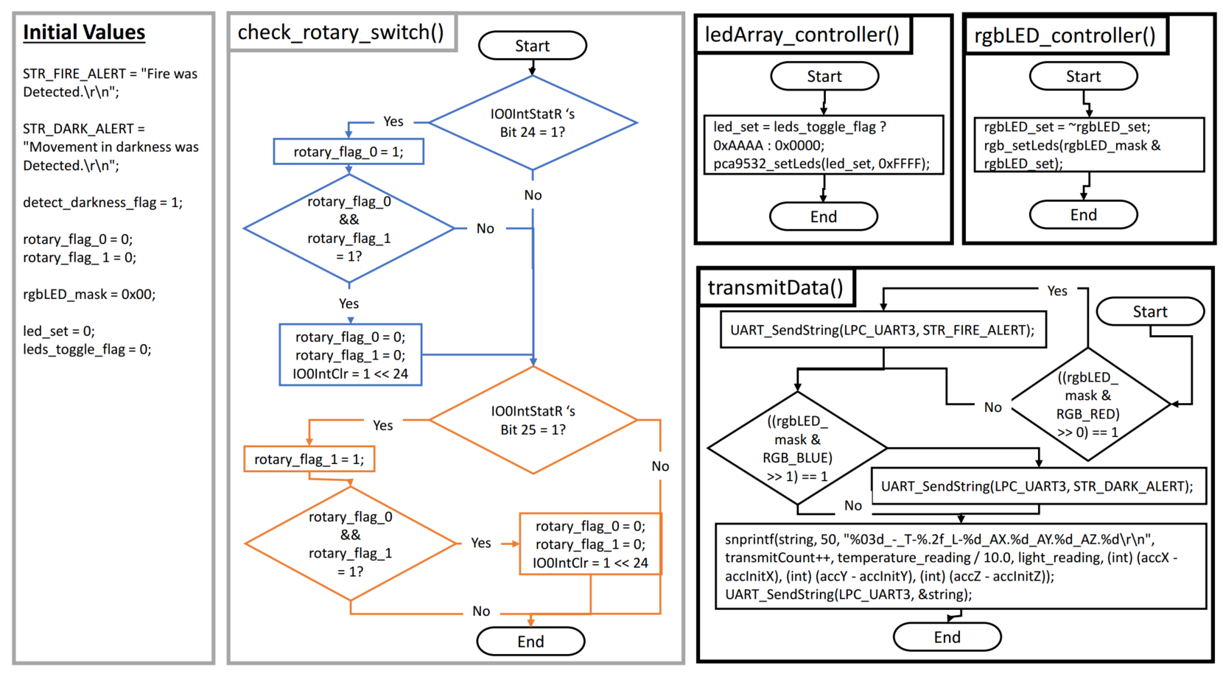

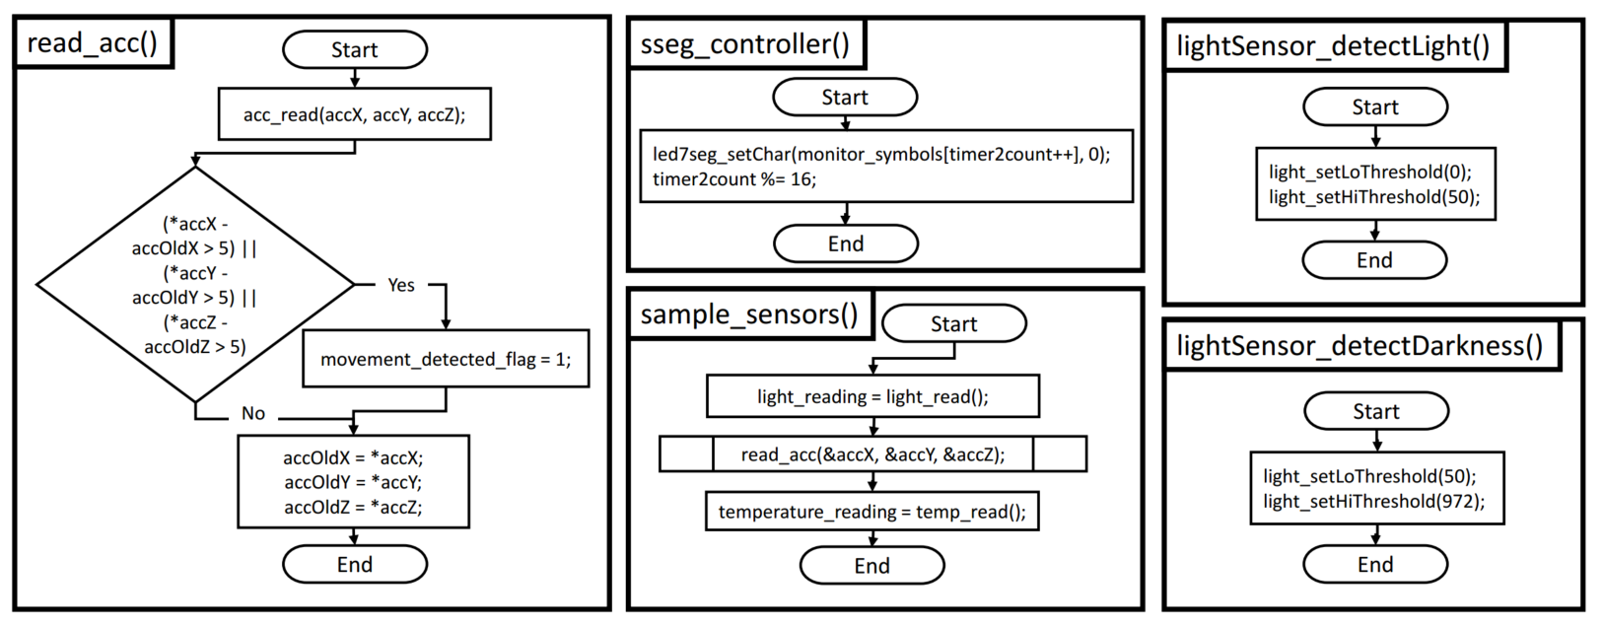

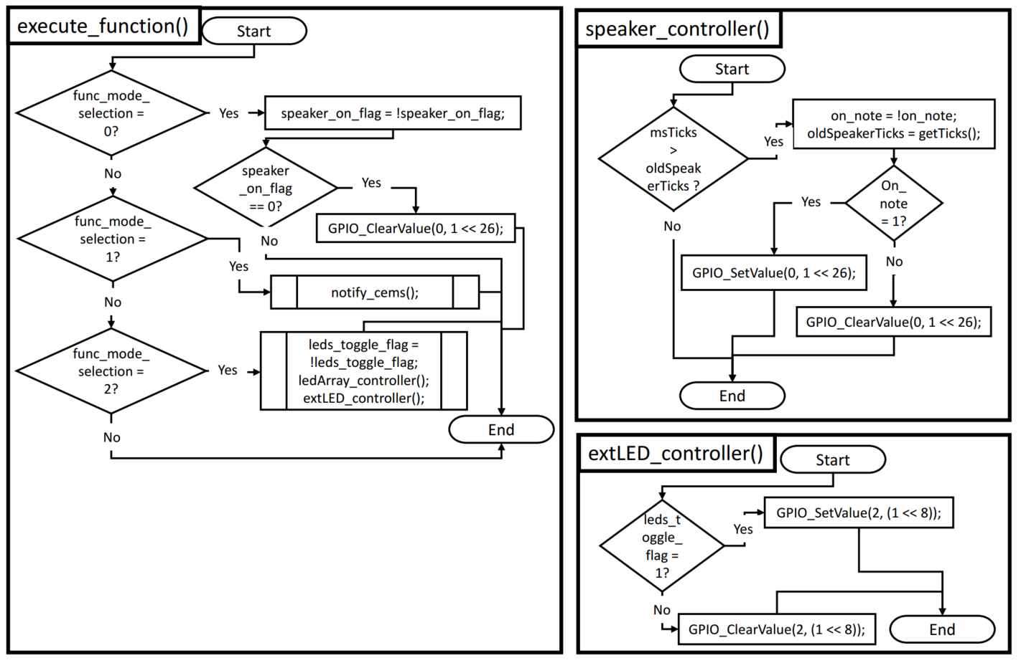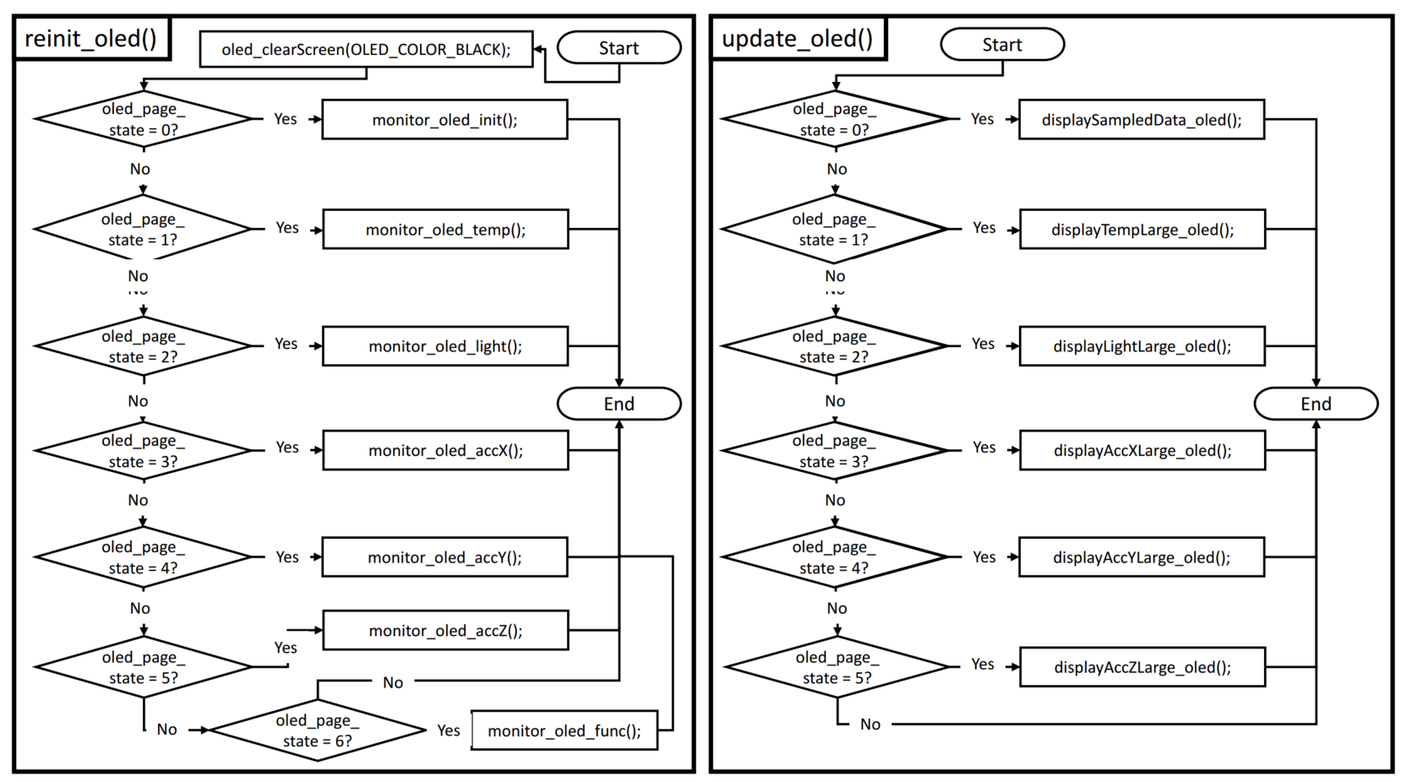

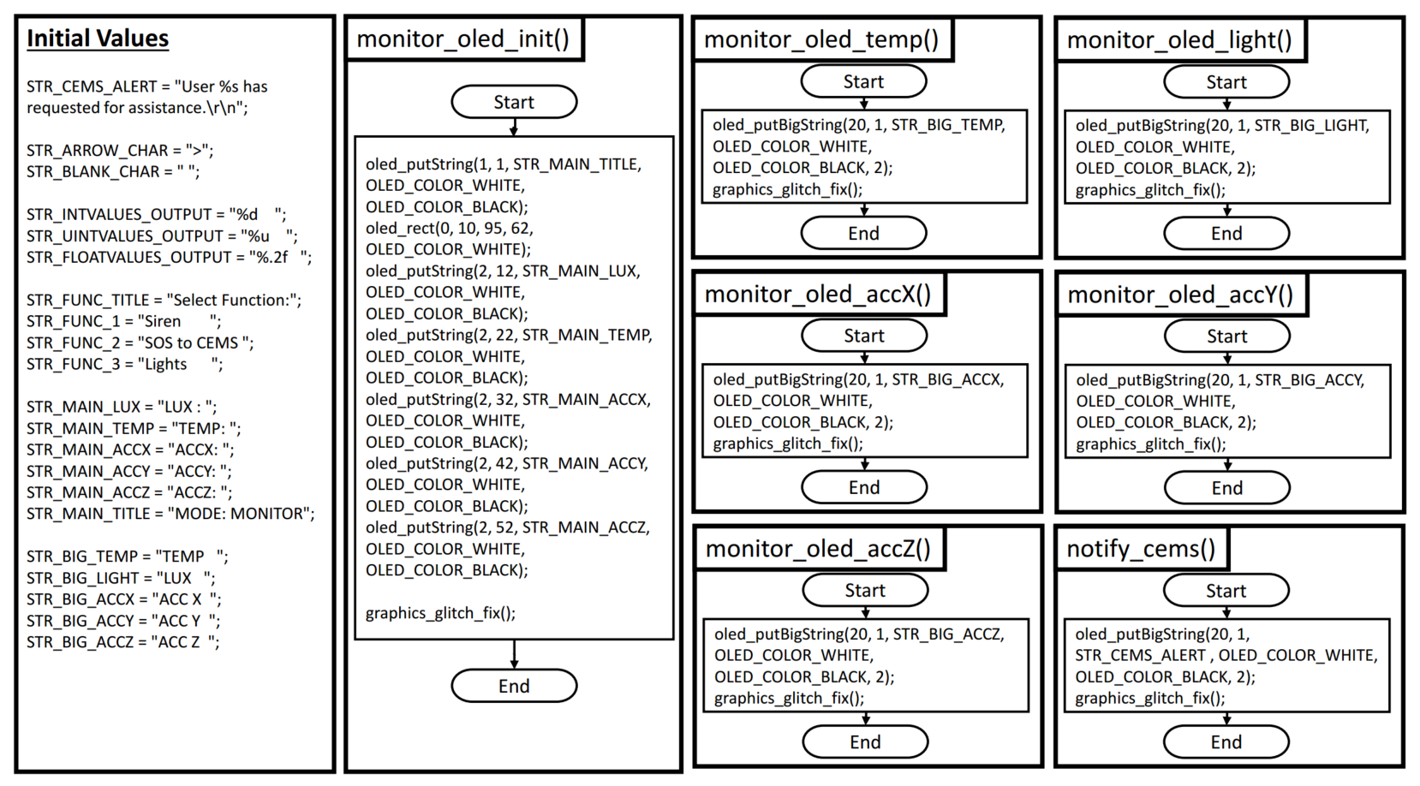

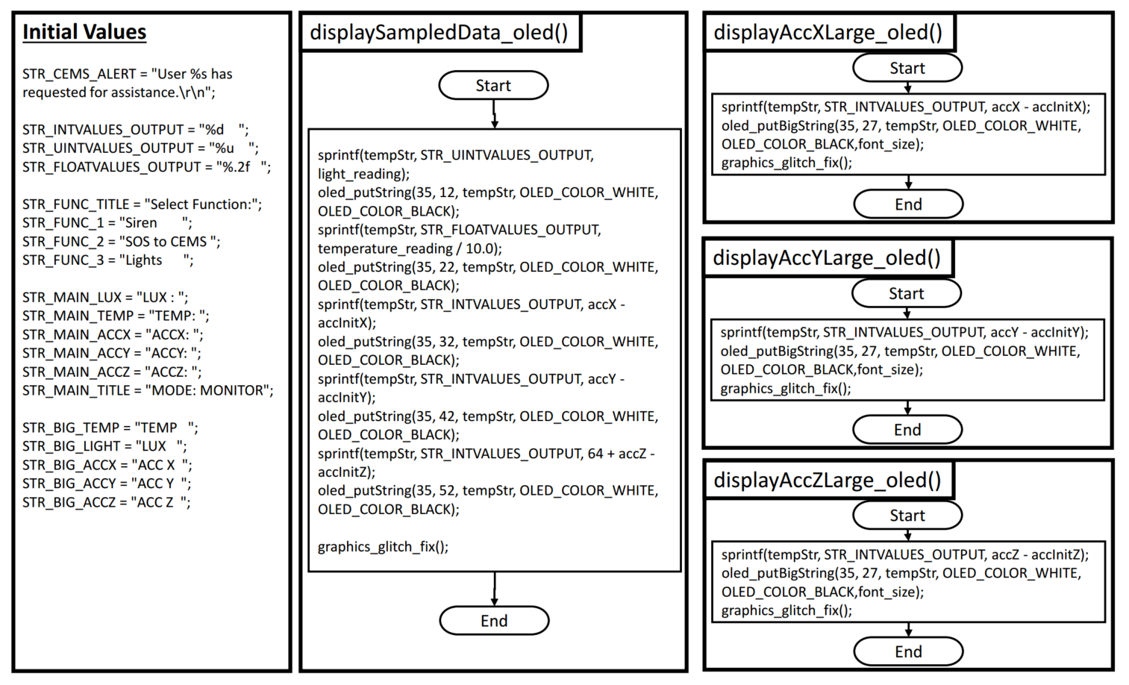

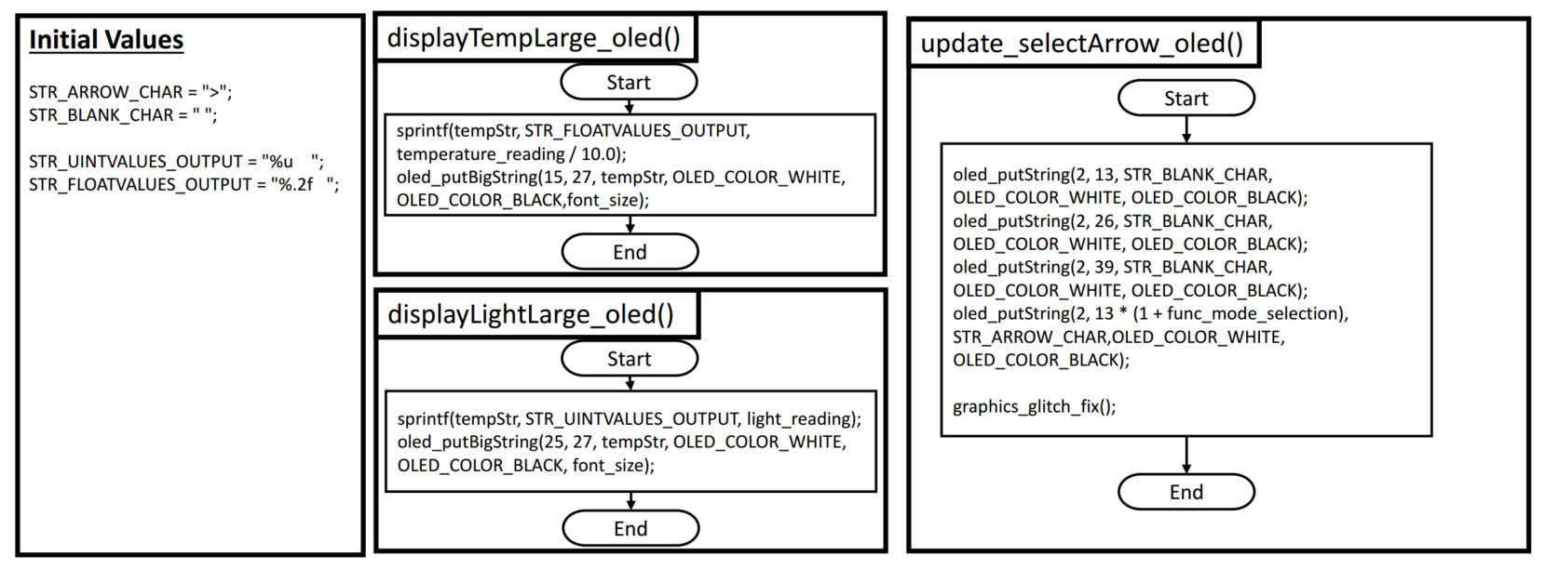

# 

# Description and Explanation of Implementation

To fulfil the objectives of the system, we first need to setup the light and temperature sensors, accelerometer as well as the pushbuttons on the baseboard. We also configured the piezo speaker, joystick and rotary switches to extend our functionality of the system. We first initialize the GPIO pin configurations by writing to the respective PINSEL registers.

## Setup for Interrupts and Handlers and Routines

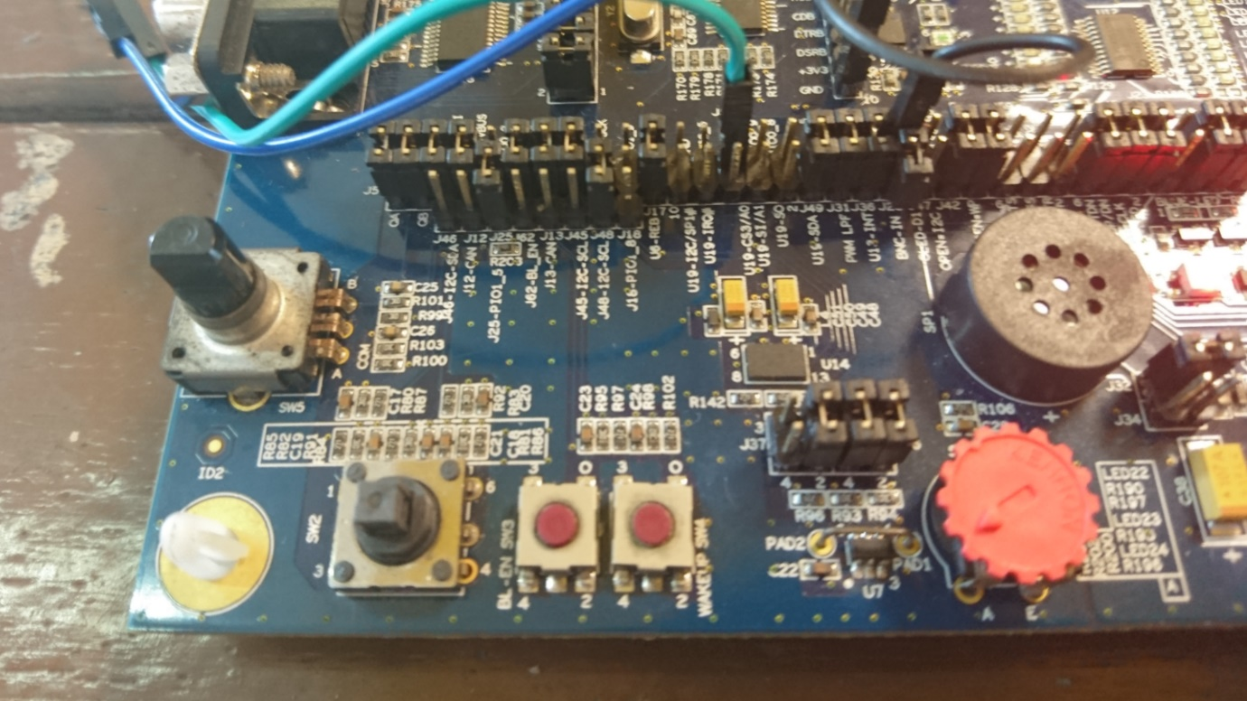

SW4 Pushbutton

SW3 Pushbutton

Figure : Location of the Pushbuttons SW3, SW4

### EINT1 Interrupt from SW4 Button

#### Hardware configuration:

1. Connect PIO1_4 to PIO2_10 (P2.11) using a jumper wire (shown as black jumper wire above)

#### Software configuration:

1. Configure the P2.11 to be connected to EINT1 by writing to PINSEL registers
2. Write EINT1 interrupt handler (EINT1_IRQHandler) to toggle a flag between PASSIVE and MONITOR modes
3. Write to External Interrupt Mode Register (0x400fc148) to set Edge Sensitive interrupt
4. Write to External Interrupt Polarity Register (0x400fc14c) to set Falling Edge interrupt
5. Clear EINT1 pending interrupts in NVIC
6. Enable EINT1 interrupts in NVIC

NOTE: Ensure SD/MMC memory card interface not used as they share PIO2_10. If so, use another unused GPIO pin from Port 0/2.

EINT1’s interrupt handler will simply toggle a global flag to tell the system which mode (passive or monitor) it should be on. The system will enter PASSIVE mode and remain there until the mode_flag is set to 1.

### EINT0 Interrupt from SW3 Button

###### Hardware configuration:

1. Connect BL_Button to PIO2_9 (P2.10) by setting the correct jumpers

###### Software configuration:

1. Configure the P2.10 to be connected to EINT0 by writing to PINSEL registers
2. Write EINT0 interrupt handler (EINT0_IRQHandler) to set func_execute_flag to indicate to run execute_function() later
3. Write to External Interrupt Mode Register (0x400fc148) to set Edge Sensitive interrupt
4. Write to External Interrupt Polarity Register (0x400fc14c) to set Falling Edge interrupt
5. Clear EINT0 pending interrupts in NVIC
6. Enable EINT0 interrupts in NVIC

EINT0’s interrupt handler will check if the system is currently in the function mode page (oled_page_state == 6) and set the func_execute_flag to 1 to tell the system to execute whichever function is currently selected later.

### Timer Interrupts for 7 Segment Display and RGB LED

###### Software configuration:

1. Write Timer interrupt handlers TIMER1_IRQHandler, TIMER2_IRQHandler
2. Set bit in PCONP register to power on timer
3. Set Match Control Register to decide what to do when Timer Counter matches MRO:

Clear TimerCounter and Generate Interrupt

1. Set Prescale Register value: Timer Counter is updated every (value + 1) of PCLK
2. Set value of Match Register 0 that triggers interrupts
3. Start Timer by setting the Counter Enable bit in Timer Control Register
4. Clear Timer pending interrupts
5. Enable Timer interrupts in NVIC

Timer 1 will trigger approximately every 0.3s by setting the MR0 to 8888888. When triggered, timer 1’s interrupt handler will call rgbLED_controller() and toggle the RGB LEDs on/off accordingly.

Timer 2 will trigger approximately every 1s by setting the MR0 to 26666666. Timer 2’s interrupt handler will set the sseg_flag to 1 to update the seven-segment display to the corresponding value in the main loop later.

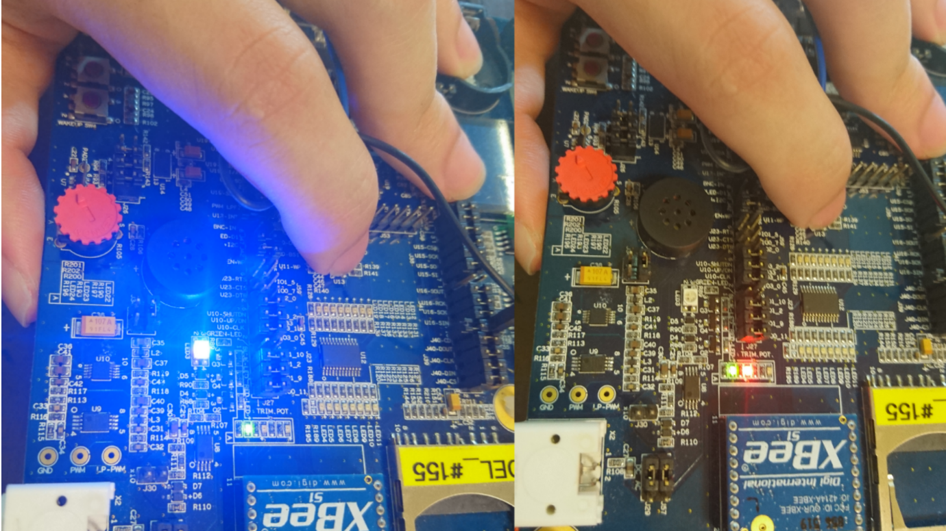

ISL29003 Light Sensor

Figure : Location of the Light Sensor (ISL29003)

### Light Interrupts

###### Hardware configuration:

1. Connect U13-INT (light sensor interrupt) to PIO2_5 (P2.5) by setting the correct jumpers
2. Ensure no other jumpers connect to PIO2_5 (eg. accelerometer interrupts)

###### Software configuration:

1. Initialize I2C protocol to communicate with light sensor
2. Write EINT3 interrupt handler (EINT3_IRQHandler) to handle light sensor interrupt
3. Initialize Falling Edge GPIO interrupt on P2.5
4. Set high and low thresholds (default is 50, 972)
5. Set the no. of integration cycles before interrupt (default is LIGHT_CYCLE_1)
6. Clear P2.5 GPIO interrupt and light sensor interrupt status
7. Clear EINT3 pending interrupts
8. Enable EINT3 interrupts in NVIC
9. Enable light sensor

We configure the light sensor to trigger an interrupt for 2 different states:

1. Currently well-lit, looking for dark\poorly-lit conditions

(set low threshold to 0, high threshold to 50)

1. Currently dark, looking for well-lit conditions

(set low threshold to 50, high threshold to 972)

Whenever the interrupt triggers, it toggles the detect_darkness_flag to tell the system whether the environment is now poorly-lit or well-lit and the low and high thresholds are set accordingly. This is so that you would not get flooded with interrupts since interrupts only need to be handled whenever there is a significant change (light to dark, dark to light) in illumination of the environment.

## Normal Functions

The functions below are normally executed in the main processing loop and will mostly be activated whenever their corresponding global flags are set.

## Sample Temperature, Light Sensors, Accelerometer

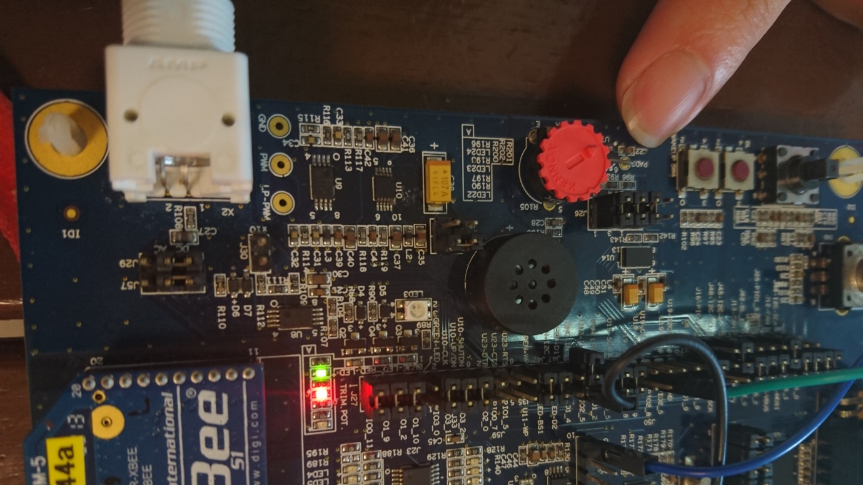

MMA7455L Accelerometer

MAX6567 Temperature Sensor

Figure : Location of the Temperature Sensor(MAX6567) and Accelerometer (MMA7455L)

The system will periodically poll for accelerometer and temperature readings approximately every **0.1s**. This is done by writing to the accelerometer’s registers through I2C and requesting for a data read and receiving the X, Y and Z acceleration values from it. The temperature reading is polled by reading the GPIO P0.6’s pin value to check for the width of the pulse produced by the temperature sensor and doing a conversion into temperature in degrees Celsius * 10.

The values are required to check for any movement detected by the board or if the temperature is over the threshold limits. If lowly-lit conditions are detected by the board along with movement, the rgbLED_mask will have its 1st bit set (0x01), which will subsequently tell the rgbLED_controller() to toggle the blue LED. If high temperatures are detected, the rgbLED_mask will have its 2nd bit set(0x02), telling the controller to toggle the red LED as well.

The light readings are also read every **5s** through the I2C protocol as well, along with the above 2 sensors.

### 7 Segment Display

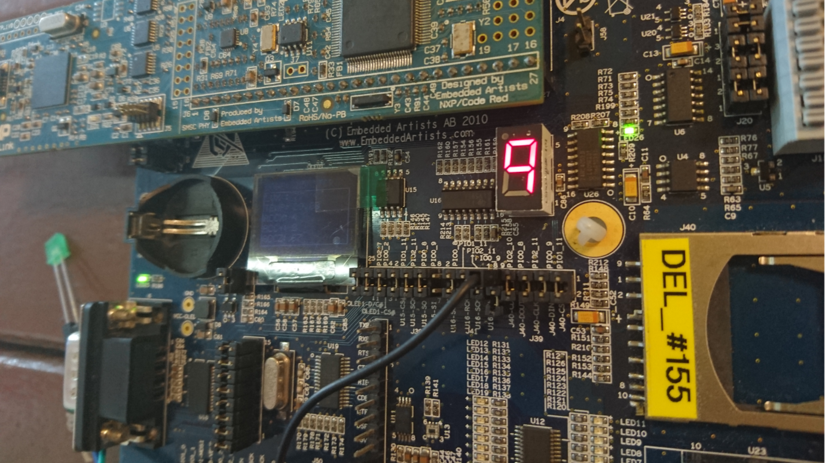

Figure : Location of the 7-segment Display

The timer interrupt handler will set the sseg_flag every **1s** to indicate that the display should be updated to its next value. The display will then be updated by the sseg_controller function. We store the characters sequentially in the monitor_symbols array which will be read sequentially and looped. The character at the current index corresponding to the value of timer2count will be displayed. The variable timer2count is then incremented. The LPC1769 board communicates with the display via the SPI protocol.

A small improvement was made in order to display the 7-segment display and the OLED in the same orientation. This is done by manually changed the character mapping of the values 0-9 and A-F in the led7seg.c of the OLED library. This was done through simple calculation of the multiplexed bits to determine which bit corresponded to which segment of the display and setting the correct bits for each character.

### OLED Display

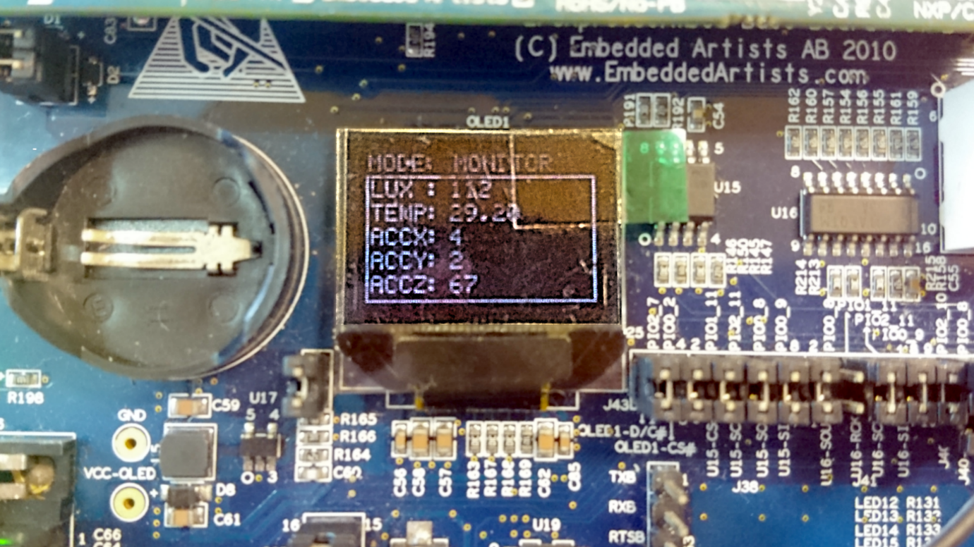

Figure : OLED Display showing Main Screen

The OLED screen is updated every **5s** and also whenever the user requests to change the screen (using the joysticks/rotary switch). This is done by writing to the OLED registers through the SSP protocol.

The OLED is updated either when there are new sensor values to display, when the user switches the page or when the user moves the cursor in the function page. Since updating the entire OLED takes a long time, we opted to only update the portions of the OLED that change, which are the sensor values.

One important thing to take note was that we had to pad the values with blank spaces at the back. This is to ensure that the new values will overwrite the old values completely, by writing over the previous values with spaces, if any. This ensures that the old values will not be shown with the new values, for example in the case where the sensor previously read a 3 digit value and now a tries to display a 1 digit value, which will cause the last 2 digits of the old value to be combined with the new value.

### UART Message Transmission

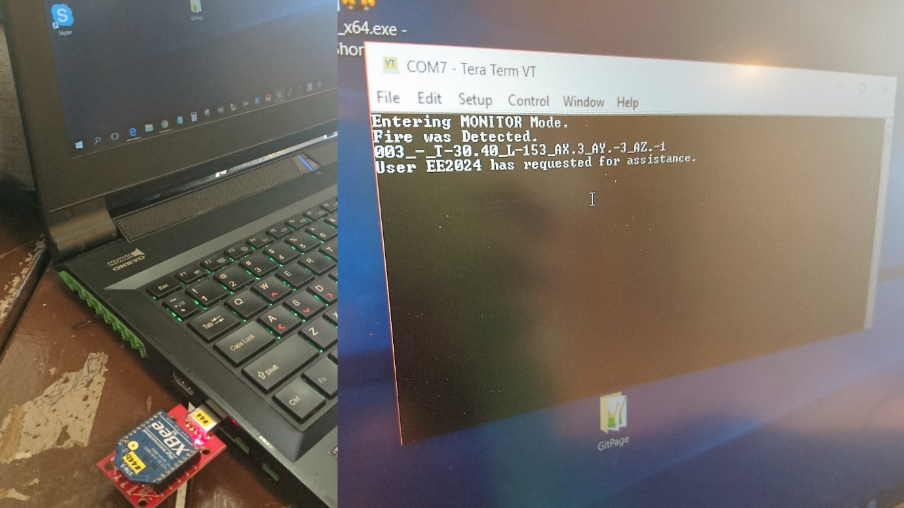

Figure : XBee S1 Module along with Serial Terminal Output

Before using the XBee modules, they both must be configured through the serial terminal first. This is done by setting their baud rates to the same value as well as their destination and source addresses. Once both modules are configured, they are ready to be used for transmission.

The LP1769 board communicates with the XBee module via the UART protocol. The XBee module then transmits serially from the baseboard to the serial terminal on the laptop.  This is required to send a message that contains the information about the current temperature, illumination, and orientation of the board (for movement detection) every **15s** to CEMS. If there is a suspected fire being detected or movement being detected in darkness, alert messages will also be sent along with the values above.

The user can also explicitly request for assistance from CEMS if required. This functionality will be explained in more detail in the next section.

# Application Logic Enhancements

To further suit the needs of the elderly, we have developed a list of further enhancements below.

* Multiple pages to display stats at larger fonts (eg. temperature, lux, accX/accY/accZ)
* Function Mode screen with ability to select different functions such as:
  + Raising alarm to alert nearby people for help
  + Sending SOS message to CEMS for assistance/help
  + Turning on a flashlight (Green LED used as example)
* User navigates UI using the Joystick and with the Rotary Switch

### Screens Displaying Larger Text

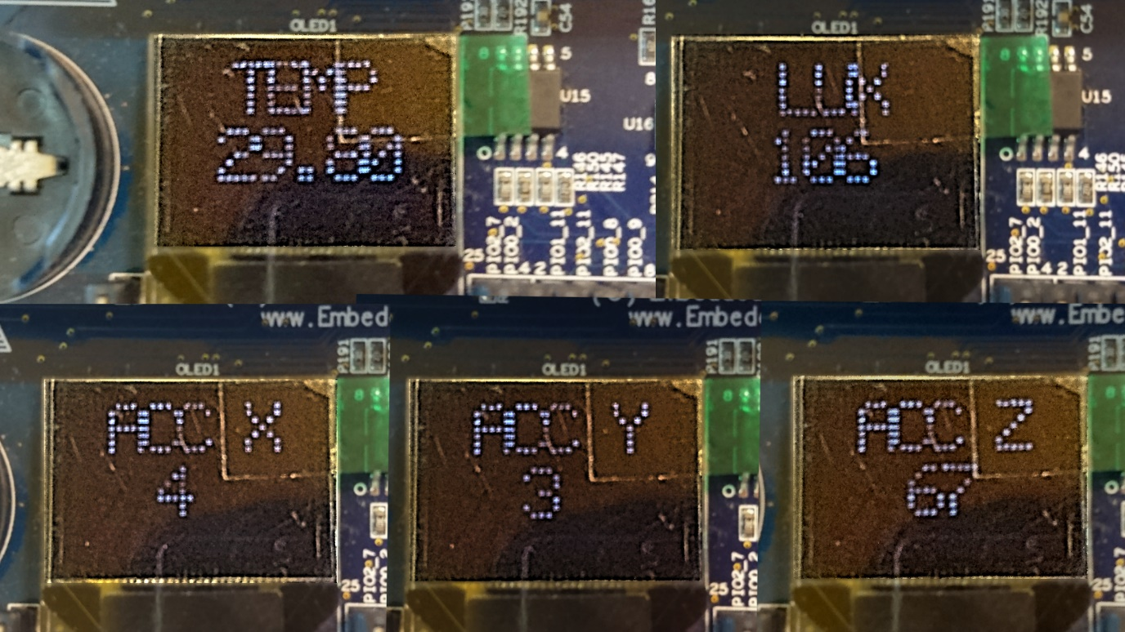

Figure : OLED Display showing Larger Values

The user can navigate to screens that will display information at larger sizes so that we can cater to elderly who may have difficulty in seeing the information on the main screen. He/she can do so by using the joystick, using the left and right switches to navigate between the pages as well as by turning the rotary switches clockwise or anti-clockwise.

Building on the default OLED library, we derived our functions called putBigPixel and putBigChar and putBigString functions. These are derived from the library’s own putPixel, putChar and putString functions. These are similar to the corresponding default functions, except that we can specify the size of the string/character to output. For example, if size is 2 then the size of a pixel will be 2x2 instead of the original 1x1. The putBigChar function will then read the 5x7 font bitmap from font5x7.c and put a big pixel in place of each X to form the character.

### Function Mode Page

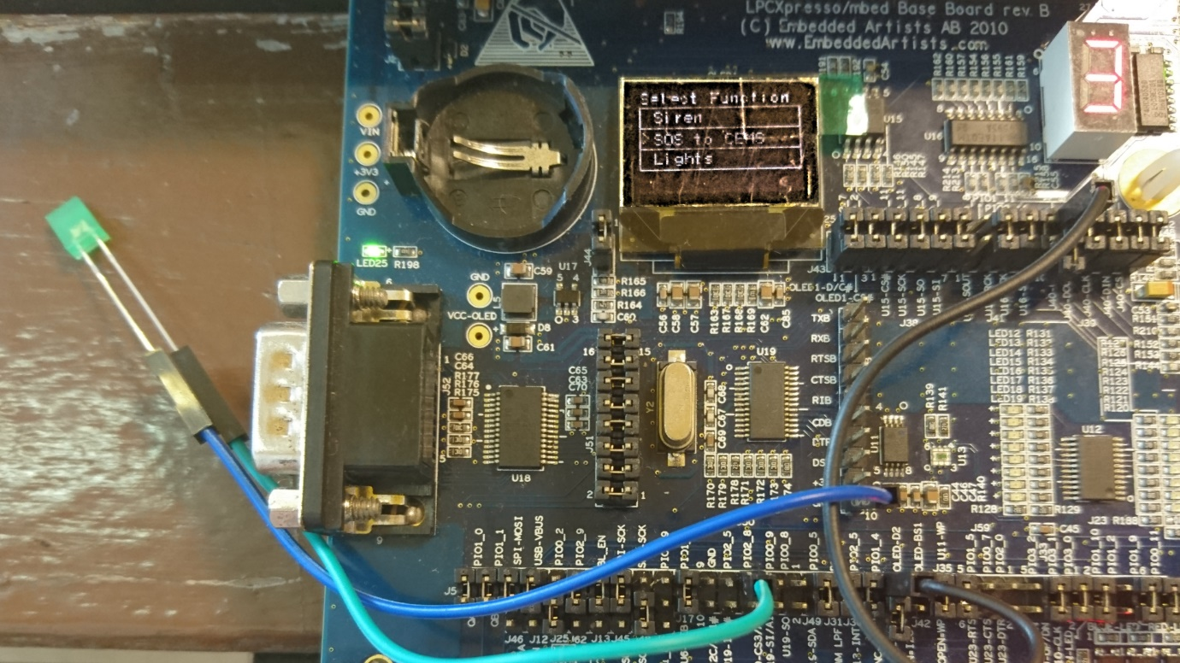

Figure : OLED Display showing Function Mode Page and Green LED

We have 3 user selectable functions that can be activated / toggled via push button SW3 through EINT0.

1. Toggle Siren on/off
2. Sends assistance/help request message to CEMS
3. Toggle LEDs and torchlight (Green LED) on/off

These functions are implemented with simple function calls. To activate the siren, we first must configure its GPIO pin directions by writing to its respective PINSEL registers. Since the on-board piezo speaker shares the same GPIO hardware lines as the RGB LEDs, activating either one would be fine. This however also means that whenever the blue LED is to be turned on or whenever the speaker is to be turned on, the other device will also be turned on. This is unavoidable since they are hardwired together although they do not affect each other’s functionalities too significantly.

The functionality to send a request for help to CEMS is done simply by calling the UART library’s send function with a preconfigured string.

The functionality to turn on the ‘flashlight’ and the LED arrays is implemented by configuring the GPIO PIO2_8 (P2.8) direction to be an output pin and writing a 1 to its value as well as configuring the port expander PCA9532 to set the corresponding LEDs on through I2C.



Joystick

Rotary Switch

Figure : Location of Rotary Switch and Joystick

### Rotary Switch and Joystick UI Navigation

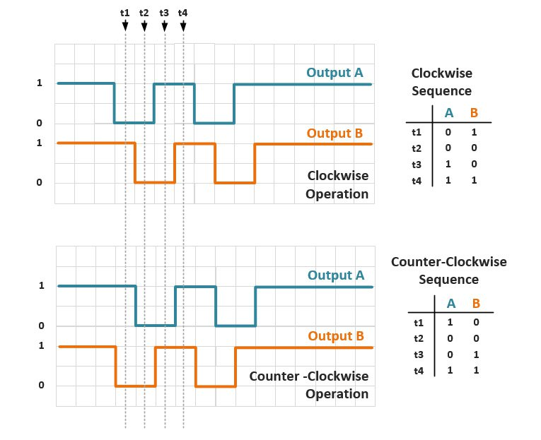

Figure : Rotary Switch Quadrature Outputs

Source: http://www.allaboutcircuits.com/projects/how-to-use-a-rotary -encoder-in-a-mcu-based-project/

The rotary switch produces 2 square wave outputs. When turned clockwise, square wave A leads the square wave B phase-wise by 90 degrees. Likewise, when turned anti-clockwise, B will lead A. To calculate the correct direction, the rotary switch is turned by, we added in a buffer for the inputs to filter out the correct output. We first enabled rising edge GPIO interrupts for each of the outputs. We set up variables to count the number of instances each wave leads the other by. For example, after detecting 10 instances of A Leading B, we can safely conclude that it is rotating clockwise.

As for the joystick, each directional input from the joystick corresponds to a GPIO pin where GPIO falling edge interrupts can be enabled. The EINT3 interrupt handler will then simply update the oled_page_state variable by incrementing/decrementing the value when the joystick is pushed right/left. At the function mode screen, the joystick can also be pushed up/down which will increment/decrement the func_mode_selection variable to select between the 3 functions in the function mode page. All the updating of the page and selection arrow in the function mode page is done separately in the main execution loop.

# Problems and Solutions

### SSP / I2C Bus Contention

We encountered a bit of trouble when we updated the 7 Segment Display in the interrupt handler. This causes a bus contention when the main loop is executing an SSP transaction (e.g. Updating OLED display) when interrupted. In the end the program hangs since the SSP library uses a blocking wait without timeouts. There were similar problems when both the interrupt and main loop executes I2C transactions. We eventually resolved this by resorting to update the 7-segment display in the main execution loop instead. This however did introduce a delay in the updating of the 7-segment as certain instances, although this was a compromise we were willing to accept in favor of a more robust system.

### Accelerometer Interrupts

We faced a lot of difficulty in attempting to use the accelerometer interrupts. We have tried multiple combinations of configurations i.e. pulse mode, level mode in different ranges, thresholds but it simply does not provide the outputs we were looking for. We believe that the interrupts were only triggered when the accelerometer detects very rapid, sharp vibrations (usually from the baseboard) such as when hitting or tapping the board. Rotating, shaking, or moving the baseboard does not trigger the interrupts, which is what we required. The documentation does not specify what could be causing this behavior and the lack of online resources/solutions eventually forced us to resort to polling the accelerometer values periodically to check for movement instead. This of course means a heavier performance impact on the system, but as the system can still function relatively well we decided to stick with it.

### OLED and RGB LED Conflict

Due to the OLED and green LED sharing the same pin PIO1_10, we had problems of the OLED not displaying properly whenever the RGB library was used. This was solved by commenting out the portion of code updating the green LED so that it will not disrupt PIO1_10 which controls the OLED voltage.

The sharing of the pin by the piezo speaker with blue LED was also mentioned as a non-issue in the previous section.

### OLED Graphic Glitches

Over time, when the OLED is left unchanged after a screen change or update, there would be some weird pixel artifacts that would periodically appear after the position of the last pixel write. We have no idea what is causing this weird effect but attempted to resolve it by simply doing a write to the last bottom right pixel after every screen change or update.

### USB Keyboard Integration Attempt

We tried to attach a USB keyboard to the baseboard to provide an alternative form of input. We found the LPCOpen libraries online and had tested the example project which had drivers to receive keyboard inputs. However, we ran into issues when trying to port that over to our code as they both had the same base libraries that differed slightly. This resulted in conflicting definitions: many of the constants were defined twice. We had learned a lot about the USB protocol through the information available online, such as the different classes of USB devices as well as the descriptors that were unique to each of them. However, we decided to scrap this extension as time was running out.

# Suggestions/Issues

Our OLED display (Board 155) is a little dim, probably due to burn-in from heavy use previously. It looks easily replaceable with its ribbon connector exposed, so maybe that can be replaced for the next user. We have already informed the lab technicians.

It would be interesting to see how far it is possible to extend this project if we were given much more time. Perhaps, increasing it to a 6MC module would allow us to do that.

# Conclusion

In conclusion, we have learned to use the different protocols to interface with different peripherals by configuring them through software. By learning about how to configure GPIO configurations, as the interrupts and how to handle them when they occur, we get a feel of how the hardware interfaces work together in an embedded system. There were very many issues that occur with hardware, as mentioned by Prof Rajesh before, that we did not expect or experience in other high level software programming modules. Resolving these issues was another challenge itself, due to the lack of resources and the uncommon and sometimes random issues that we cannot find solutions for, online or with the resources we have. With the knowledge of how the different protocols work (SSP/SPI, I2C, UART), we get a better feel of what is going on even when we only simply call their API using the preconfigured libraries. We also got a chance to put the knowledge into practice by designing and developing a working prototype which was quite an enriching experience.

This was quite an interesting project that allowed us a great deal of freedom to explore programming and interfacing with the many peripherals available on the baseboard. After a mere 13 weeks, we feel significantly more confident to program low-level hardware. Terms such as 'volatile' and 'interrupts' used to be so foreign to us, but in the end, we almost had a double-digit number of interrupts in our system. Of course, the hard part is to use them in a real-time system where hard deadlines come into play. This module also allowed us to appreciate how higher level code in Python or Java will eventually be simplified into reading and writing registers.